COLORISING IMAGES

Abstract
The Colorise Images project is an application that breathes life into monochromatic photographs by adding realistic colours. Utilizing a blend of Generative Adversarial Networks (GANs) for their exceptional image generation capabilities, and segmentation techniques for precise differentiation of image regions, this tool offers a sophisticated solution for image colorization.
GANs are employed to predict and apply colours that are visually appealing and contextually appropriate, while segmentation ensures that these colours stay within the lines, accurately mimicking natural colour boundaries. The intricate process involves training on diverse datasets to understand the nuanced relationship between different objects and their true-to-life colours. Python serves as the foundation for the implementation, harnessing libraries such as TensorFlow for constructing the GANs, and OpenCV, potentially alongside imutils, for image pre-processing and segmentation tasks. This system not only enhances the aesthetic of black and white imagery but also serves as a portal to the past, allowing us to view historical photographs in a new light.

Table of Contents
COLORISING IMAGES 1
STUDENT NAME 1
Abstract 1
Chapter 1: Introduction to Colorization Technology 3
Chapter 1.1 What is Image Colorization? 3
Chapter 1.2 The Significance of Colorization 4
Chapter 1.3 Technologies Powering Colorization 5
Chapter 1.4 Chapter Layout 6
Chapter 2: Technology Behind Colorization 8
Chapter 2.1 Generative Adversarial Networks (GANs) 8
Chapter 2.2 Image Segmentation 9
Chapter 2.3 Implementation of GANs 10
Chapter 3: Technical Details 13
Chapter 3.1 Data Collection and Preparation 13
Chapter 3.2 Designing the GAN Architecture 13
Chapter 3.3 Implementing Segmentation 15
Chapter4: Code implementation 17
Chapter 4.1 Project pipeline 17
Chapter 4.2 Code Overview 17
Chapter 4.3 Code explanation. 19
Chapter 4.4 Results 24
Chapter 5: Conclusion and Future Scope 26
Chapter 5. 1 Challenges Faced during Development 26
Chapter 5. 2 Conclusion 26
Chapter 5. 3 Future Scope 26
Reference 27

Chapter 1: Introduction to Colorization Technology
Colorization technology refers to the process of adding colour to monochrome images or videos, thereby enhancing their visual appeal and providing a more lifelike representation of the depicted scenes. This technology utilizes various algorithms and machine learning techniques to automatically identify and assign appropriate colours to different elements within the image. Initially, colorization was a manual process, requiring skilled artists to painstakingly add colour to each part of the image. However, with advancements in artificial intelligence and computer vision, automated colorization methods have become increasingly sophisticated and accessible. One common approach involves training deep neural networks on large datasets of both black-and-white and colour images. These networks learn to predict the most probable colours for grayscale pixels based on contextual information and patterns present in the training data. Modern colorization algorithms can accurately infer colours for different objects, landscapes, and even skin tones, producing realistic and visually pleasing results. Additionally, users can often fine-tune the colorization process by providing reference images or adjusting parameters to achieve desired outcomes.
Colorization technology finds applications in various fields, including historical preservation, entertainment, and digital restoration, allowing old photographs and films to be revitalized with vibrant colours and renewed relevance.
- What is Image Colorization?
Image colorization is the process of adding colour to black and white or grayscale images. Historically, this task was performed manually, often painstakingly, by artists or photographers. However, with advancements in technology, especially in the field of artificial intelligence and deep learning, automated methods for image colorization have emerged. In automated image colorization, algorithms analyse the grayscale image and predict plausible colours for different objects and regions based on learned patterns and relationships from a vast dataset of coloured images. These algorithms typically employ deep neural networks, specifically convolutional neural networks (CNNs), which are trained on large collections of colour images paired with their grayscale counterparts. Image colorization has various applications, including restoring and enhancing historical photographs, bringing old movies and videos to life, and enabling creative expression by transforming monochrome images into vibrant, colourful compositions. Additionally, it serves as a valuable tool in fields like digital art, design, and visual storytelling.
Definition and Historical Context
Colorizing images refers to the process of adding colour to black and white or grayscale photographs or films to make them appear more lifelike and vibrant. This technique is primarily employed in visual media restoration, historical documentation, and artistic expression. It involves digitally or manually applying colours to different elements within the image, such as people, objects, and backgrounds, based on historical accuracy, artistic interpretation, or personal preference.
Historical Context:
Colorizing images has a rich historical context that spans several decades. Prior to the advent of colour photography, all photographs were monochrome, capturing only shades of gray. As a result, significant events, cultural moments, and everyday life from the past were documented in black and white. However, as technology progressed, so did the desire to see these moments in colour.
Evolution from Manual to AI-Driven Techniques
The evolution from manual to AI-driven techniques in colorizing images has been a fascinating journey that reflects advancements in both technology and methodology.
Manual Techniques:
Historically, colorizing images was a painstakingly manual process. Artists would meticulously add colour to black and white photographs or drawings using various methods like painting, airbrushing, or even hand-tinting.
This process required a significant amount of skill, time, and expertise. Each image had to be carefully analysed to determine appropriate colours and shading.
Introduction of Digital Tools:
With the advent of digital technology, manual colorization gradually transitioned to digital platforms. Basic software tools were developed to aid artists in adding color to images.
These early digital tools provided features like selecting colors, painting within defined areas, and adjusting opacity. However, the process remained largely manual and time-consuming.
Machine Learning and AI:
The breakthrough in colorization came with the application of machine learning and AI algorithms. These algorithms were trained on vast datasets of color images and their corresponding black and white versions.
Convolutional Neural Networks (CNNs) and Generative Adversarial Networks (GANs) are commonly used in this context. CNNs can learn features from images, while GANs can generate realistic-looking colorizations.
By analysing patterns and relationships between grayscale and colour images, AI models can accurately predict appropriate colours for different elements within a scene.
- The Significance of Colorization
Colorization of images holds significant value in various fields, ranging from historical preservation to artistic expression. One of its primary functions is to breathe life into black-and-white photographs, allowing viewers to connect with the past in a more immediate and relatable manner. By adding colour, these images become more accessible and engaging, fostering a deeper understanding and appreciation of historical events, figures, and everyday life colorization plays a crucial role in reviving cultural heritage. It helps bridge generational gaps by making historical moments feel relevant and tangible to contemporary audiences. Through the addition of colour, previously monochromatic images can evoke emotions and stir memories, fostering a sense of connection across time.
Enhancing Visual Perception
Enhancing visual perception in colorizing images involves the process of adding colour to grayscale or black-and-white images to make them more visually appealing and understandable. This process is particularly significant in historical photographs or artistic renderings where the original colours are absent or faded. By applying various techniques such as machine learning algorithms, deep learning models, or manual colorization methods, grayscale images can be transformed into colourful representations that closely resemble reality. Not only does this enhance the aesthetic appeal of the images, but it also aids in conveying information more effectively, allowing viewers to better comprehend the context and details of the depicted scenes. Additionally, advancements in technology have enabled the development of sophisticated colorization tools that offer greater control and precision, enabling artists and historians to recreate accurate and vivid depictions of the past. Overall, enhancing visual perception through colorization contributes to preserving cultural heritage, improving educational materials, and enriching the viewing experience for audiences across various domains.
Cultural and Historical Importance
Colorizing images holds cultural and historical significance by providing a vivid portrayal of the past. By adding colour to black and white photographs, these images become more relatable and accessible to modern audiences, bridging the gap between past and present. This process allows viewers to better understand and connect with historical events, figures, and everyday life by seeing them in a more realistic and familiar light. Additionally, colorized images can evoke emotions and memories, making historical moments feel more immediate and tangible. They offer a fresh perspective on the past, shedding new light on familiar scenes and offering insights into the lives of people who lived in different eras. colorizing images enriches our cultural heritage by preserving and revitalizing historical visuals, ensuring that they remain relevant and impactful for generations to come.
- Technologies Powering Colorization
Several technologies contribute to this fascinating endeavour. Primarily, deep learning algorithms, particularly convolutional neural networks (CNNs), have revolutionized the field of image colorization. These networks are trained on vast datasets of both black and white and colour images, learning the intricate relationships between grayscale values and corresponding colours. Through this learning process, they can predict the most probable colours for different parts of an image. Techniques like Generative Adversarial Networks (GANs) have also been employed to refine the colorization process, enhancing the realism of the results. Additionally, advancements in computer vision and image processing techniques play a crucial role, enabling algorithms to better understand context and semantics within images, leading to more accurate colorizations. Furthermore, the availability of powerful hardware, including GPUs and TPUs, accelerates the computational intensity of these algorithms, allowing for faster and more efficient colorization. Together, these technologies combine to unlock the potential for transforming historical black and white imagery into vivid and lifelike colour representations, preserving and revitalizing visual narratives from the past.
Overview of Generative Adversarial Networks (GANs)
Generative Adversarial Networks (GANs) have revolutionized the field of image processing, including the task of colorizing images. In the context of colorization, GANs employ a unique architecture consisting of two neural networks: the generator and the discriminator. The generator network is tasked with generating plausible colorized versions of grayscale images, while the discriminator network evaluates the authenticity of these colorizations. Through a competitive process, the generator aims to produce colorizations that are indistinguishable from real coloured images, while the discriminator learns to distinguish between real and generated colorizations. GANs for image colorization can be challenging due to the large variability in color distributions across different images and the subjective nature of color perception. Ensuring stability and convergence during training requires careful tuning of hyperparameters and architectural choices. Despite these challenges, GANs have demonstrated remarkable success in colorizing images, offering a promising avenue for automating the process of adding colour to grayscale images in various applications such as historical photo restoration, entertainment, and medical imaging.[5]
Role of Image Segmentation
Image segmentation plays a crucial role in colorizing images by dividing the image into meaningful regions or segments based on certain characteristics such as colour, texture, or brightness. By segmenting the image, the colorization process can be applied more accurately and efficiently to individual regions rather than treating the entire image as a single entity. This allows for finer control over the colouring process, enabling realistic and detailed colorization results. Additionally, image segmentation helps in preserving the boundaries between different objects or elements within the image, preventing colour bleeding and ensuring that each region receives appropriate colours that correspond to its content. Image segmentation enhances the quality and precision of the colorization process, resulting in visually appealing and lifelike coloured images.
- Chapter Layout
Chapter 1: Introduction to Colorizing Images
Provide an overview of the importance and applications of colorizing images.
Discuss the significance of colorization techniques in preserving historical images, enhancing visual content, and enabling creative expression.
Chapter 2: Technology Behind Colorization
This part delves into the pivotal role of Generative Adversarial Networks (GANs) and Image Segmentation Techniques, underscoring their collaborative synergy in advancing the realm of image colorization.
Chapter 3: Technical Details of Colorization
Dive into the technical aspects of colorization algorithms, including traditional methods and modern deep learning approaches.
Examine the role of convolutional neural networks (CNNs), generative adversarial networks (GANs), and other advanced models in automatic colorization.
Chapter 4: code implementation
Provide a detailed overview of the project pipeline for colorizing images.
implementation of colorization algorithms, including integration with libraries.
Showcase code examples and walkthroughs to demonstrate colorization techniques in action.
Chapter 5: Challenges, Conclusion, and Future Directions
Discuss challenges encountered during the colorization process, such as dataset limitations, computational constraints, and colour consistency issues.
Draw conclusions about the effectiveness of different colorization methods and their potential applications.
Outline future research directions and enhancements for advancing colorization technology, such as improving realism, handling complex textures, and extending to video colorization.

Chapter 2: Technology Behind Colorization
Colorizing images using Generative Adversarial Networks (GANs) and Convolutional Neural Networks (CNNs) involves a sophisticated interplay of deep learning techniques. GANs, consisting of a generator and a discriminator, work in tandem to generate realistic images. In colorization tasks, the generator learns to produce colorized versions of grayscale images, while the discriminator learns to distinguish between real colour images and those generated by the generator. CNNs play a crucial role in this process by providing the underlying architecture for both the generator and the discriminator. The generator typically employs an encoder-decoder architecture, where the encoder extracts feature from the input grayscale image, and the decoder generates the corresponding colorized version. CNN layers within the encoder and decoder facilitate feature extraction and mapping between grayscale and color spaces. Additionally, skip connections may be incorporated to enhance information flow and preserve spatial details during the colorization process.
- Generative Adversarial Networks (GANs)
Generative Adversarial Networks (GANs) in colorizing images is an innovative application of deep learning where two neural networks, the generator and the discriminator, work in tandem to produce vibrant, realistic colorizations of grayscale images. In this context, the generator network takes grayscale images as input and generates colorized versions, while the discriminator network evaluates the generated colorizations to discern whether they resemble real color images or not. Through an iterative process, the generator improves its ability to create lifelike colorizations by learning from the feedback provided by the discriminator. Meanwhile, the discriminator also refines its ability to distinguish between real and generated color images. This adversarial training dynamic pushes both networks to improve continuously, resulting in impressive colorizations that preserve texture, detail, and realism. GANs in colorizing images have shown remarkable success in various applications, including restoring old photographs, enhancing medical imaging, and generating synthetic imagery for entertainment and design purposes.

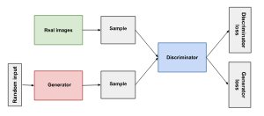
Figure: Generated Data Discriminator into Real Data [1]
Role in Image Colorization
The role of image colorization in colorizing images is multifaceted and impactful. Essentially, it involves the process of adding color to monochrome or grayscale images, breathing new life into historical photographs, artistic renderings, or even enhancing contemporary visuals.
One primary role of image colorization is historical preservation and restoration. By adding colour to black and white photographs, particularly those capturing significant historical events or moments, we can bridge the temporal gap between the past and present, making these images more relatable and accessible to contemporary audiences. This restoration process can help evoke a sense of connection with the past, enabling viewers to better understand and empathize with the people and events depicted.[4]
- Image Segmentation
Image segmentation techniques play a crucial role in colorizing images by dividing the image into distinct regions or segments based on certain attributes such as color, texture, or intensity. These techniques essentially help in identifying different objects or areas within an image, which is essential for accurately applying color to each segment. One common approach is semantic segmentation, which involves assigning a specific label or category to each pixel in the image based on its content, such as identifying objects like sky, grass, buildings, and people. Another technique is instance segmentation, which not only labels pixels but also distinguishes between different instances of the same object, allowing for more precise colorization. Furthermore, there are techniques like clustering-based segmentation, where similar pixels are grouped together based on their color or feature similarity, enabling effective colorization by treating each cluster as a separate segment. Overall, image segmentation techniques provide the necessary foundation for accurately colorizing images by breaking down the complex visual information into manageable segments for targeted color application.
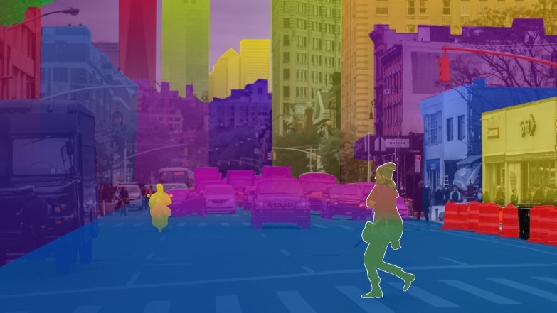
Figure: Various stages of Image Segmentation[2]
Importance in Colorization
Colorization is a process that adds colour to monochrome images, bringing them to life and offering a fresh perspective on historical moments or personal memories. The importance of colorization lies in its ability to enhance the visual experience and make images more relatable and engaging to modern audiences. By adding colour, details that might have been lost in black and white photos become vivid and prominent, allowing viewers to connect more deeply with the subject matter. Colorization can also help bridge the gap between past and present, making historical events feel more immediate and relevant. Moreover, it allows for greater artistic expression, enabling creators to evoke specific moods or atmospheres through the strategic use of color. colorization enriches our visual culture by breathing new life into old images and expanding our understanding of the past.
Techniques and Tools
Python is a highly versatile and widely-used programming language in the field of data science and machine learning. Its simplicity and readability make it accessible for beginners, while its powerful libraries like TensorFlow enable advanced users to implement complex algorithms effectively. Python's extensive ecosystem is ideal for tasks ranging from simple automation to large-scale machine learning applications, making it a preferred choice for developing cutting-edge technology in image processing and artificial intelligence.
Algorithms
Generative Adversarial Networks (GANs) and image segmentation are pivotal in the realm of computer vision. GANs involve two neural networks—the generator and the discriminator—that compete against each other, enhancing the generation of new, synthetic images that are indistinguishable from real images. This makes GANs ideal for tasks like photo-realistic image generation and image colorization, where they help in adding realistic colors to grayscale images.
Image segmentation, on the other hand, divides an image into segments to simplify or change the representation of an image into something more meaningful and easier to analyze. It is crucial for tasks where understanding the context and details within images is necessary, such as medical imaging, object recognition, and autonomous driving. Both algorithms leverage deep learning techniques to improve accuracy and efficiency in processing and analyzing images.
- Implementation of GANs
TensorFlow and PyTorch are popular libraries utilized for GAN implementation in Python, offering convenient high-level APIs for constructing and training neural networks, thus making them well-suited for GAN applications.
Implementation Steps:
- The generator and discriminator networks can be easily defined using TensorFlow neural network modules, simplifying network construction and training.
- The training loop involves alternating between training the generator and discriminator, with the generator creating fake images and the discriminator distinguishing between real and fake images to improve GAN performance.
- Binary cross-entropy loss functions can be used to train the GAN, measuring the difference between generated and real images. The Adam optimizer can also optimize the GAN's performance.
- Tuning hyperparameters like learning rates, batch sizes, and network architectures is crucial for enhancing the GAN's performance, improving image generation and discrimination capabilities for a more effective model.
Synergistic Effects
Synergistic effects in colorizing images refer to the enhancement or improvement achieved when multiple techniques or methods are combined to achieve a better result than what could be attained by any single method alone. In the context of image colorization, this typically involves the fusion of different algorithms, approaches, or models to accurately add color to black and white or grayscale images. synergistic effects in colorizing images demonstrate the power of integrating complementary techniques to achieve superior results, surpassing the capabilities of individual methods in isolation. This collaborative approach opens up possibilities for more accurate and compelling colorization in various applications, including historical photo restoration, artistic rendering, and medical imaging.
Challenges and Solutions
- Colour Accuracy: Ensuring that the colours used are accurate to the real-life scene or object depicted in the image can be difficult, especially when dealing with historical or artistic images where colour references may be scarce.
- Solution: Researching historical context or reference images can help in determining accurate colours. Additionally, leveraging advanced AI algorithms that analyse colour distributions in similar images can assist in making informed colour choices.
- Detail Preservation: Maintaining the fine details and textures present in the original black and white image while adding colour can be challenging. Over-colorization can lead to loss of detail or a less realistic appearance.
- Solution: Utilizing techniques such as selective colorization, where colours are applied only to specific areas while leaving others grayscale, can help preserve details. Additionally, adjusting the opacity of colour layers can create a more subtle effect, allowing underlying details to shine through.
- Gradient Handling: Black and white images often contain subtle gradients that may be lost or distorted during colorization, leading to a flat or unnatural appearance.
- Solution: Using software tools that allow for precise control over gradients, such as gradient maps or gradient masks, can help recreate smooth transitions between colour. Manually painting gradients with soft brushes can also achieve more natural results.
- Skin Tones and Complex Textures: Colorizing portraits or images with human subjects requires special attention to accurately reproduce skin tones and complex textures like hair or fabric.
- Solution: Studying color theory and anatomy can aid in selecting appropriate skin tones. Utilizing layers and blending modes to add depth and texture to the skin can create a more lifelike appearance. Additionally, incorporating reference photos or studying real-life subjects can improve accuracy.
- Consistency Across the Image: Ensuring that colors are consistent and harmonious throughout the entire image is crucial for achieving a cohesive and believable result.
- Solution: Creating a color palette or swatch reference based on the image's theme or setting can help maintain consistency. Regularly stepping back to view the image as a whole and making adjustments as needed can ensure uniformity.

Chapter 3: Technical Details
- Data Collection and Preparation
- Historical Images: If colorizing historical images, collecting a diverse range of high-quality black and white images is essential. These images should cover various subjects, time periods, and styles to train a robust colorization model.
- Modern Images: For contemporary images, sourcing high-resolution black and white images with clear details and textures is important. These images serve as both training data and references for colorization.
- Metadata: Collecting metadata such as image descriptions, dates, and any available color references can provide valuable context for the colorization process.
Sources of Monochromatic Images
Monochromatic images, commonly referred to as black and white or grayscale images, serve as the primary source material for colorizing images. These images can be sourced from various sources, each offering unique opportunities and challenges for the colorization process. Historical archives and collections house a wealth of monochromatic photographs capturing moments from the past, ranging from iconic events to everyday scenes. Artistic works, such as sketches, line drawings, and lithographs, provide another rich source of monochromatic imagery, offering intricate details and textures ideal for colorization.[3]
Data Pre-processing with Python
- Noise Reduction: Removing noise and artifacts from the images can improve the quality of the training data. Techniques like denoising filters or image enhancement algorithms can be applied.
- Image Alignment: Ensuring that all images are properly aligned and scaled helps maintain consistency during training. This is especially important when dealing with datasets containing images of varying sizes or orientations.
- Normalization: Normalizing the images to a standardized format, such as a specific size or color space, can simplify the training process and improve model performance.
- Augmentation: Augmenting the dataset by applying transformations such as rotation, flipping, or color jittering can increase its diversity and help prevent overfitting.
- Designing the GAN Architecture
Designing a Generative Adversarial Network (GAN) architecture for colorizing images involves crafting a network that can effectively generate realistic colorized versions of black and white images. Typically, a GAN consists of two neural networks: a generator and a discriminator. The generator network takes in grayscale images as input and outputs colorized versions, while the discriminator network evaluates the generated images for realism, distinguishing between real color images and those produced by the generator. Balancing the complexity and capacity of these networks is crucial to achieving high-quality results. The generator network often comprises convolutional layers followed by up sampling layers to gradually increase the resolution of the output image. Batch normalization and activation functions like ReLU are commonly used to stabilize and introduce non-linearity into the network. The discriminator network also consists of convolutional layers, with downsampling layers to reduce the resolution of the input image. Training a GAN involves iteratively optimizing the generator and discriminator networks in a minimax game, where the generator aims to fool the discriminator into accepting its generated images as real, while the discriminator strives to accurately distinguish between real and generated images. Fine-tuning the network architecture and hyperparameters, along with techniques like feature matching and spectral normalization, can improve the stability and convergence of the GAN training process. Additionally, incorporating perceptual loss functions based on feature similarity metrics like VGG or perceptual loss networks can enhance the visual quality and realism of the colorized images.
Components of GANs
- Generator Network:
Takes grayscale images as input and produces colorized versions.
Comprises convolutional layers that learn to map grayscale pixels to corresponding colour values.
- Discriminator Network:
Evaluates the realism of colorized images produced by the generator.
Distinguishes between real color images and those generated by the generator.
- Loss Function:
Guides the training process by quantifying the difference between generated colorized images and ground truth colour images.
Common loss functions include adversarial loss and perceptual loss.
- Training Procedure:
Involves iteratively updating the generator and discriminator networks in an adversarial fashion.
The generator aims to produce increasingly convincing colorizations to fool the discriminator.
The discriminator aims to distinguish between real and generated images accurately.
Customizations for Colorization
Customization options in colorizing images allow users to tailor the colorization process to their specific preferences and requirements, enhancing flexibility and control over the final result. These customizations typically encompass a range of parameters and settings that can be adjusted to achieve desired outcomes:
- Color Palette Selection: Users may have the option to choose from predefined color palettes or create custom ones to match specific artistic styles or historical references. This customization enables the adaptation of color choices to suit different contexts and aesthetics.
- Colorization Style: Customizing the colorization style allows users to emulate various artistic techniques or historical color trends. Options may include realistic colorization, sepia tones, or artistic filters that impart a particular mood or atmosphere to the image.
- Brush Size and Opacity: Adjusting brush size and opacity provides finer control over the colorization process, allowing users to apply colors with varying degrees of precision and blending. This customization is especially useful for detailing intricate areas or achieving subtle color transitions.
- Region Selection and Masking: Advanced customization options may include the ability to selectively apply color to specific regions or objects within the image. Users can define masks or boundaries to isolate areas for targeted colorization, enabling more precise editing and enhancement of details.
- Color Adjustment Tools: Customizable color adjustment tools allow users to fine-tune individual color channels or overall color balance to achieve desired tonal variations and harmonies. This level of control enhances the ability to create nuanced and visually compelling colorized images.
- Implementing Segmentation
Python offers a range of libraries such as OpenCV, scikit-image, and TensorFlow/Keras that provide a variety of tools and functions for image processing and segmentation tasks.
Implementation Steps:
- To prepare the input images for segmentation, it is necessary to perform pre-processing tasks such as resizing and normalization.
- Depending on the specific requirements of the task, an appropriate segmentation algorithm or model should be chosen. This could be based on factors like semantic segmentation or instance segmentation.
- The selected segmentation algorithm can be implemented using the functions and modules available in libraries such as OpenCV or TensorFlow/Keras.
- If deep learning-based approaches are being used, it is recommended to fine-tune the segmentation model on a labelled dataset to improve its performance.[6]
Selection of Segmentation Methods
- Segmentation is Key: It helps identify different parts of the image for accurate color application.
- Various Methods Exist: Different techniques are available, each with strengths and weaknesses.
- Traditional Techniques: These include basic methods like thresholding, edge detection, and region growing.
- Advanced Methods: Semantic segmentation, like CNNs or FCNs, automatically categorizes image parts (e.g., sky, grass) using deep learning.
- Enhances accuracy and efficiency by adding pre-processing steps like edge detection or texture analysis.
Integration with Colorization Process
Integration with the colorization process in colorizing images involves seamlessly incorporating data-driven techniques, algorithms, and human expertise to achieve accurate and visually appealing results. Integration involves sourcing diverse and high-quality black and white images, along with any available color references or metadata. These datasets are meticulously cleaned, pre-processed, and labelled to ensure they are suitable for training machine learning models or guiding manual colorization efforts. integration with the colorization process involves a harmonious blend of automated techniques, human expertise, and iterative refinement, all working together to produce colorized images that are accurate, realistic, and visually compelling. This collaborative approach ensures that the strengths of both machine learning algorithms and human creativity are maximized, resulting in the best possible outcomes for colorizing images.

Chapter4: Code implementation
- Project pipeline
- Data Collection and Preparation:
Gather a diverse dataset of black and white images from various sources, including historical archives, art collections, and modern photography.
Collect any available colour references or metadata associated with the images.
Clean and pre-process the dataset, removing noise, aligning images, and normalizing them to a standardized format.
- Data Labelling and Annotation:
Manually label a subset of the dataset by colorizing images or annotating colour regions for supervised learning.
leverage semi-automated tools or crowdsourcing platforms for efficient labelling.
- Model Selection and Training:
Choose a suitable colorization model architecture, such as Convolutional Neural Networks (CNNs) or Generative Adversarial Networks (GANs).
Split the dataset into training, validation, and testing sets.
Train the chosen model using the labelled dataset, adjusting hyperparameters and regularization techniques to optimize performance.
- Model Evaluation:
Evaluate the trained model on the validation set to assess its performance in colorizing images accurately.
- Testing and Validation:
Conduct thorough testing of the deployed model across different use cases and input scenarios.
Validate the colorized outputs against ground truth or human judgment to ensure quality and accuracy.
- Code Overview
The main.py and deploy.py scripts you've provided are integral parts of implementing the pix2pix framework for image-to-image translation, specifically tailored for tasks such as photo-realistic rendering from sketches or colorizing grayscale images. Here’s an overview of how these scripts function within your project:
main.py Overview
This script handles the core operations for training the pix2pix model. It includes:
- Library Imports and Constants: Utilizes TensorFlow for model construction and training, and matplotlib for visualization.
- Dataset Preparation: Configures the dataset, leveraging TensorFlow's data API to efficiently load and pre-process images. This includes functions for image resizing, normalization, and augmentation (like random jitter and cropping to enhance training robustness).
- Model Architecture: Defines the generator and discriminator using sequential models, incorporating convolutional layers for feature extraction and transposed convolutions for image generation.
- Loss Functions: Implements custom loss functions to optimize both generator and discriminator, focusing on the adversarial nature of training and the L1 loss to preserve image content.
- Training Routine: Orchestrates the training process, including data loading, model updates, loss calculations, and periodic image generation for visual feedback.
- Checkpointing: Manages model saving during training, allowing for recovery or resumption without starting over.
deploy.py Overview
This script is dedicated to deploying the trained model for generating images from new inputs. It includes:
- Model Loading: Reloads a trained model from saved weights, ensuring that the deployment uses the exact configuration and parameters optimized during training.
- Image Pre-processing: Prepares input images for the model, mirroring the pre-processing steps used during training to ensure consistency in how images are handled.
- Image Generation: Uses the model to generate outputs from input images and visualizes them next to the inputs for comparison.
Integration and Functionality
These scripts showcase a robust workflow for using deep learning for image-to-image translation:
- Integration: The main.py script manages training, which is computationally intensive and typically run on high-performance hardware, possibly in a cloud environment. deploy.py is then used in a more lightweight environment where the model’s predictions are needed, such as a production server or a user interface.
- Functionality: Together, these scripts encapsulate the full lifecycle of a machine learning project—from training and validation to deployment and application.
- Code explanation.
A detailed explanation of each part of the main.py script used for image-to-image translation with the pix2pix framework. Let’s go through key snippets of the code, explaining their function and significance in the process.
main.py
Import Statements and Constant Definitions
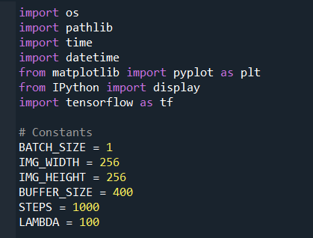
- Libraries: Essential Python libraries are imported, including TensorFlow for machine learning, matplotlib.pyplot for plotting, and os and pathlib for file management.
- Constants: These define various settings used in the model training process, like batch size, image dimensions, and training steps.
Path Configuration and Metric Setup
- Logging: Set up logging for TensorBoard, which helps in visualizing the training progress over time.
Dataset Loading Functions
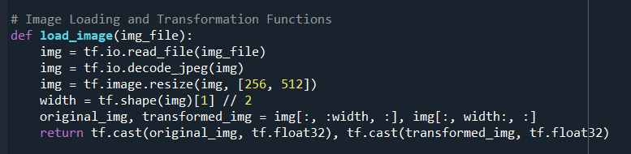
Image Loader: This function reads an image file, decodes it to a JPEG format, resizes it, and splits it into original and transformed halves, typically used in the training of GANs for image-to-image translation.
Image Processing Functions
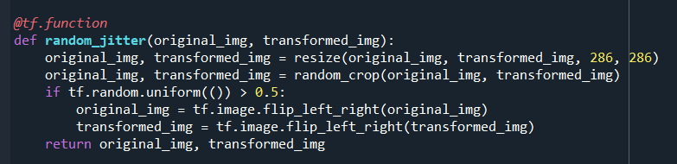
Augmentation: Implements image resizing, cropping, and random flipping as forms of data augmentation to help the model generalize better.
Model Architecture
Generator: Builds the generator model using an encoder-decoder architecture with skip connections (U-Net style). It down samples the input to a bottleneck and then up samples it to generate the output image.
Training and Loss Functions
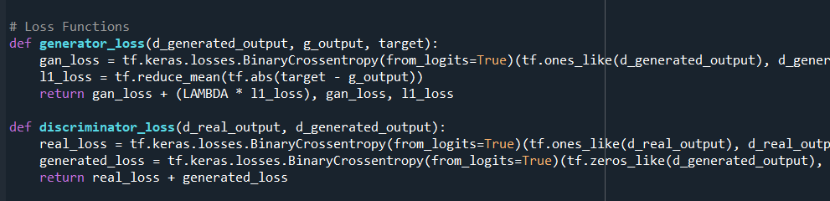
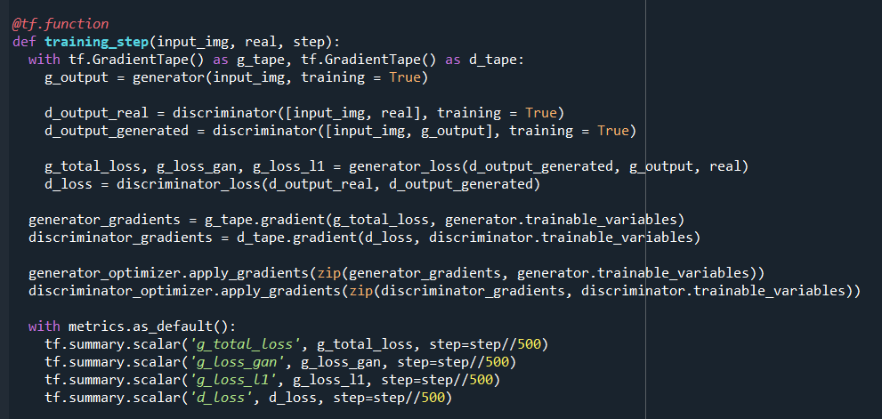
- Loss Functions: Defines loss functions for the generator and discriminator. The generator loss includes an L1 loss component to ensure the generated image is close to the target image.
- Training Step: Encapsulates the training logic, using gradient tapes to monitor and apply gradients based on the calculated losses.
Full Training Loop
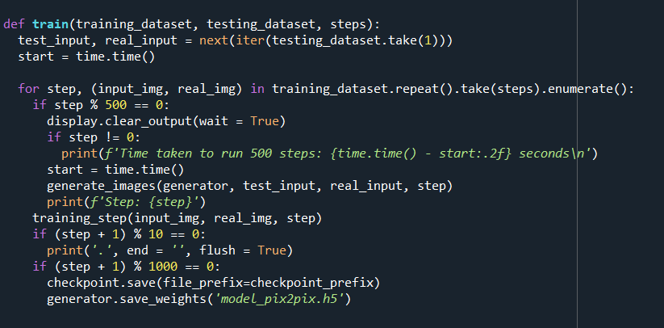
Training Loop: Manages the entire training process, iterating over the dataset, performing training steps, and periodically outputting sample images to monitor progress visually.
Each component of the code is carefully designed to handle specific aspects of the training process for a GAN-based image-to-image translation model. The structure facilitates clear separation of concerns, making it easier to adjust and scale individual parts of the model as needed.
deploy.py
In the deploy.py script, the primary focus is on deploying a pre-trained pix2pix model to generate images from new inputs. The code is structured to load the model, preprocess input images, and then use the model to generate outputs. Here's a detailed breakdown of each component in the script:
Import Statements
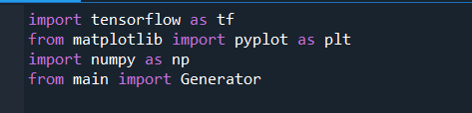
- TensorFlow (tensorflow): Used for all machine learning operations including loading models and preprocessing images.
- Matplotlib (pyplot): Used for plotting images in Python; here it's used to display the input and generated images.
- NumPy (np): While it's imported here, it's not directly used in the provided script. Typically, it would be used for numerical operations that are more complex or not directly supported by TensorFlow.
- Generator from main: Imports the Generator function from the main.py script which defines the generator component of the GAN. This ensures that the same model architecture used for training is used during deployment.
Load Model Function
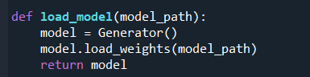
Functionality: This function initializes a new instance of the generator model, then loads pre-trained weights from a specified file path (model_path). This setup is critical for deployment because it allows the use of a model trained on potentially vast and computationally expensive datasets without needing to retrain.
Image Pre-processing Function
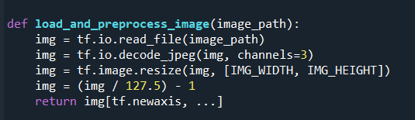
Functionality: This function loads an image from a file, decodes it from JPEG format, resizes it to the dimensions expected by the model (256x256 in this case), normalizes the pixel values to the range [-1, 1] (a common practice in neural network processing), and adds a batch dimension. This preprocessing is necessary to ensure that the input image is in the correct format and scale for the model to process.
Generate Image Function
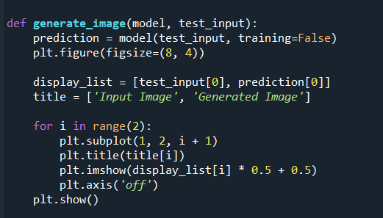
Functionality: This function takes a model and a pre-processed test input image, runs the model to generate an output, and then plots both the input and output images side by side. The training=False argument in the model call ensures that the model's behaviour is set for inference (not training), which can affect elements like dropout and batch normalization. The images are scaled back to [0, 1] before displaying, which reverses the earlier normalization.
Main Execution Block
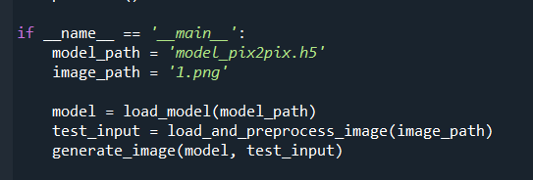
Functionality: This part of the script sets the model path, loads the model, pre-processes an input image, and then uses the model to generate and display an image. This block is the operational core of the script, ensuring that everything is correctly wired up to process an image from disk and visualize the results.
This deploy.py script is streamlined for operational use, focusing on loading the trained model and applying it to new images. It's designed for ease of use, with clear separation of concerns in its functions, making it adaptable to different deployment environments or needs.
- Results

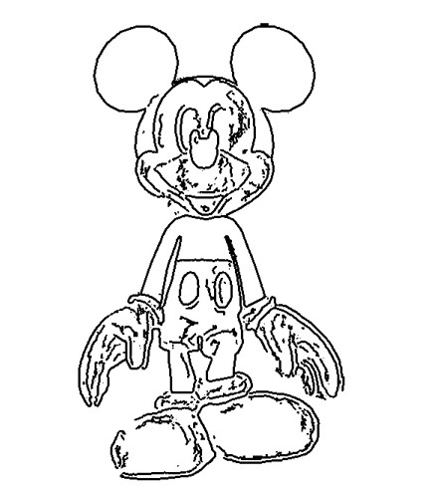

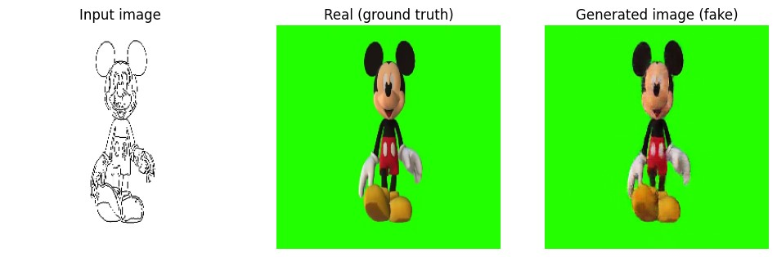

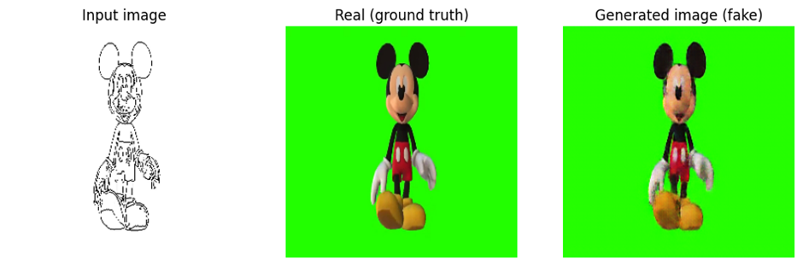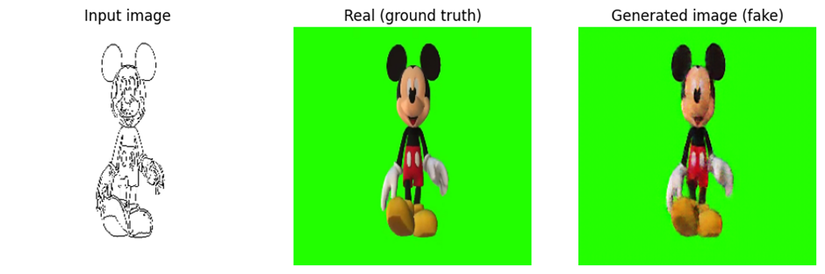
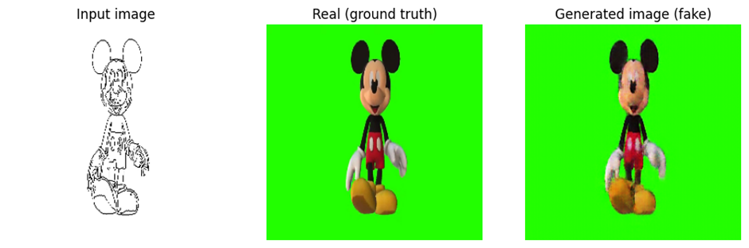

Chapter 5: Conclusion and Future Scope
- Challenges Faced during Development
During the development of the image colorization project, several challenges were encountered, including balancing the generator and discriminator in the GAN to prevent mode collapse, where the generator starts producing limited varieties of outputs. Data pre-processing, particularly ensuring consistency in image quality and size across datasets, also proved challenging. Additionally, tuning hyperparameters for optimal training results and managing computational resources effectively were significant hurdles due to the intensive nature of training deep learning models.
- Conclusion
This project successfully implemented a GAN framework for the colorization of grayscale images, effectively transforming monochromatic photos into vibrant, colorized outputs. The achievement demonstrates the potential of GANs in handling complex image-to-image translation tasks, enhancing the accessibility and appreciation of historical images. The model not only improved the aesthetic quality of the images but also helped in better visualizing and understanding historical contexts, thus bridging a gap between past and present visual experiences.
- Future Scope
Future enhancements could include integrating more sophisticated GAN architectures like Style GAN for even more realistic colorization results. Exploring the application of transfer learning could reduce training times and resource consumption. Additionally, implementing better mode collapse prevention techniques and expanding the dataset to include a wider variety of image types could further improve model robustness and generalization. Research could also explore real-time colorization capabilities, expanding the project’s applicability to live video streams and enhancing user interactivity and customization features.

Reference
- TechVidvan, ”Colorize Black & White images using Deep Learning,” Deep Learning Project - Colorize Black & White Images with Python - TechVidvan
- Hao Wang; Xuedong Liu,”Overview of image colorization and its applications,” Overview of image colorization and its applications | IEEE Conference Publication | IEEE Xplore
- Michael Elliott, “Importance and Motivation Behind colorizing monochromatic photographs,” The Art of Monochrome. Why Black and White Photography is More… | by Michael Elliott | Full Frame | Medium
- Hens Patel,” Image Colorisation with GAN Model,” Image Colorisation with GAN Model | by Hens Patel | Medium
- Overview of GAN Structure,” Overview of GAN Structure | Machine Learning | Google for Developers
- ​​Mindy Support,” The basic and Key Techniques of Image Segmentation,” What is Image Segmentation: The Basics and Key Techniques | Mindy Support Outsourcing (mindy-support.com)
- W3schools,” Introduction to Python,” Introduction to Python (w3schools.com)
- Overview of GAN Structure,” Overview of GAN Structure | Machine Learning | Google for Developers
- ​​Mindy Support,” The basic and Key Techniques of Image Segmentation,” What is Image Segmentation: The Basics and Key Techniques | Mindy Support Outsourcing (mindy-support.com)
- Mindy Support, Figure[2],”The Various Stages of Image Segmentation,” https://mindy-support.com/wp-content/webp-express/webp-images/doc-root/wp-content/uploads/2022/10/blog-11.jpg.webp
- ANURAG SINGH CHOUDHARY, ”Using GANs in TensorFlow Generate Images,” Using GANs in TensorFlow Generate Images - Analytics Vidhya
- Figure [1],” Generated Data Discriminator into Real Data,” https://developers.google.com/static/machine-learning/gan/images/gan_diagram.svg
- ANURAG SINGH CHOUDHARY, Figure[3],”Generative Adversarial Network,”https://av-eks-lekhak.s3.amazonaws.com/media/__sized__/article_images/U11ntitled-thumbnail_webp-600x300.webp
- Hanahan Huang a, Xin Jin b c, Qian Jiang b c, Li Liu a “,Deep Learning for Image Colorisation“, Deep learning for image colorization: Current and future prospects - ScienceDirect
- Stage Zero,” diverse datasets used for training,” Data diversity and its importance in AI | StageZero Technologies
- Wrike Blog ,”Project Pipeline and Implementation,” Streamlining Project Pipeline: Your Complete Guide | Wrike

